KADİR HAS UNİVERSITY, MANAGEMENT INFORMATION SYSTEMS
UniTrade

MIS 414 Term Project Final Report
Enver Erman
Ali Gökay Bozok
Fezanur Gülbuz
Muhammed Talha Navruz

E-COMMERCE BUSINESS MODEL

Submitted by:
Group Number: 8
Contact Person Name: Fezanur Gülbuz
Contact Person e-mail: fezanur.gulbuz@stu.khas.edu.tr

Group Members and Contributions
- Fezanur Gülbuz
- Enver Erman
- Ali Gökay Bozok
- Muhammed Talha

Submitted version:
version #1

Std Name |  | Specify for which ToC section the feedback was sent and what it was…
 | 1 |  | 2 | 3 | 4 | 5 | 6 | 7 | 8
Fezanur Gülbuz
Enver Erman |  |  | Context diagram has been fixed to improve visibility and accuracy.
Ali Gökay Bozok
Muhammed Talha Navruz

Specify Changes made on this document:

- Refined the business idea and clarified the campus-based C2C model
- Expanded SWOT analysis with clearer weaknesses and threats
- Improved the context diagram explanation based on feedback
- Added value proposition, target segment, revenue model, and competitive strategy sections
- The diagram now contains English statements, also now external entities are unique and all flows in noun format.
- Revised the document structure according to the ToC

1. The name of the company, its legal status to be expected
Company Name:
UniTrade
Legal Status / EC Type:
Campus-based C2C e-commerce marketplace, supported by mobile commerce features.
Expected Structure:
A digital intermediary platform that connects verified university students for buying, selling, and renting second-hand academic materials.

2. EC idea, Strengths & weaknesses of the idea, Context Diagram
EC Idea:
UniTrade is a campus-based C2C platform created for university students who want to buy, sell, or rent second-hand academic materials within their own university community. The idea comes from a simple problem: many students need textbooks and similar materials for only one semester, but buying them new is often expensive. Instead of letting these materials go unused after the course ends, the platform gives students a way to pass them on to others who need them. In this way, UniTrade helps make academic materials cheaper, easier to find, and more practical for student life. Since the platform is limited to verified students, it also aims to create a safer and more reliable environment than general second-hand marketplaces.
Strengths of the Idea:
One of the strongest parts of this idea is that it focuses on a very specific and easy-to-reach target group, which is university students. This is important because students often deal with high textbook prices and limited budgets, so the platform answers a real need. Another strong side is the campus-based structure. Because users are in the same university environment, transactions can happen more quickly and more easily. This also makes the process feel safer. Compared to general second-hand platforms, a system limited to verified students can create more trust between users. In addition, the idea encourages reuse, so it is not only useful for students financially, but also supports more sustainable consumption.
Weaknesses of the Idea:
At the same time, the idea also has some weaknesses. The biggest one is that the platform depends heavily on student participation. If there are not enough users or listings, students may not find what they need, and the platform may not seem useful. Another limitation is that being campus-based can also slow growth in the beginning, especially if the system stays too limited to one location. The rental option may also create some practical problems, such as late returns, damaged materials, or disagreements between students. Because of this, the platform would need clear rules and some level of moderation to work smoothly.

Context Diagram Explanation:
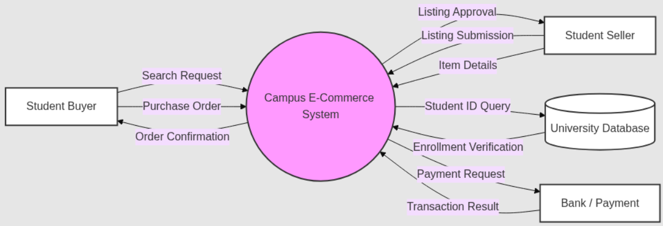

In the context diagram, the UniTrade System is shown at the center because it is the main platform that connects all parts of the process. The main external user is the student, who can use the system both as a buyer and as a seller. The university database is included to verify whether the user is an active student, which is important for keeping the platform secure and limited to the campus community. Another external component is the bank or payment system, which handles payment requests and transaction results. The data flows in the diagram show the basic interaction between these parts. For example, students send search requests, listing submissions, and purchase orders to the system, while the system sends confirmations and approvals back to them. At the same time, the system communicates with the university database for verification and with the payment provider for secure payment processing. Overall, the diagram shows that UniTrade is built around a simple but controlled structure that supports both trust and convenience.

3. Value Propositions
UniTrade gives value to university students by helping them find academic materials at lower prices. Instead of buying new and expensive textbooks for only one semester, students can buy cheaper second-hand ones from other students in their own university. The platform also feels safer than general second-hand websites because only verified students can use it. Another good side of the platform is that it supports reuse, so materials do not go to waste after one student finishes using them.

3.1. Choice of Focal Customer Benefits
The main customer benefits of UniTrade are lower prices, easy access, and trust. Lower prices are the most important because many students have limited budgets and textbooks can be expensive. Easy access is also important because students can find what they need more quickly and often within their own campus. Trust is another important benefit since the platform is only for verified university students, which makes buying and selling feel safer.
Selected Questions (from Appendix B)
Key Issue: Core Products/Services
• What value or benefit do we provide for our customers?
We offer students affordable second-hand alternatives to expensive textbooks and provide a secure shopping experience through a verified on-campus community.
• Are there substitutes for our products or services?
Yes there are alternatives such as Sahibinden, Letgo, social media groups, and bulletin boards in university hallways exist, but none of them have a verified student community and an academically focused filtering system.

Key Issue: Supplement Products/Services
• How important are the supplement products or services?
Supplementary services are quite important like the messaging system, review, comment feature, and course-based search filters enhance the basic shopping experience.
• How do we increase customer value by improving or redesigning business processes?
We can offer automatic book matching by integrating with university course catalogs. For example we can also improve the user experience with semester start and end reminder notifications.

3.2. Target Segment
The main target group of UniTrade is university students in Turkey, especially undergraduate students who often need course materials and look for cheaper options. It can also be useful for first-year students, exchange students, and students with limited budgets. The platform is more helpful for students in departments where textbooks and printed materials are used a lot.
Selected Questions (from Appendix B)
Key Issue: Market Attractiveness
• How substantial is the market segment?
There are over 8 million registered university students in Turkey, the vast majority of whom purchase course materials each semester.
• What is the growth rate of the market segment?
Hundreds of thousands of newly enrolled students enter the market each year, and rising book prices are accelerating the shift towards second-hand demand.

Key Issue: Intensity of Market Competition
• How intense is the competition?
General second-hand platforms like Sahibinden and Letgoor Dolap and social media groups create competition. However, there is currently no directly campus-focused and verified academic competitor for now.
• How large are the entry and exit barriers?
Entry barriers are low because platform development costs are low. But, reaching a sufficient user base will be the biggest barrier.

4. Scope of Offerings
UniTrade focuses on second-hand academic materials for university students. The platform mainly includes textbooks and other study-related items that students may need during the semester. It is more focused than general second-hand platforms, because it is made for student needs.

4.1. Customer Decision Process
The process starts when a student needs a textbook or another study material. The student enters the platform, searches for the item, and looks at different options by checking the price, condition, and seller. After choosing the best option, the student contacts the seller or continues with the buying process. Then the item is received on campus or through an agreed meeting point.
Selected Questions (from Appendix B)
Key Issue: Prepurchase
• How do we make it easy for customers to obtain and compare product- or service-related information?
Firstly, categorizing the books for sale by subject teacher or code makes it easier to find them. By placing the same or similar products side-by-side, we can see which seller is offering the cheapest price. Additionally, by implementing a seller rating system, we can measure which seller is more reliable and which has higher ratings.
• Do we need to obtain a third-party certificate or verification in order to build a trust relationship with our customers?
The most effective way to achieve this is to implement mandatory student verification. This means only people with email addresses ending in ".edu" will be able to sell products on the system. Using SSL certificates will also add to the credibility.

Key Issue: Purchase
• When, where, and how do customers make the purchase?
Sales typically increase at the beginning of semesters or during midterm/final exam periods. Buyers can browse and purchase products through the Uni-Trade website. The buyer searches for the product on the website, finds it, and decides to purchase it. Once found, they click the purchase button. Payment can be made securely via the website or through IBAN transfer.
• Is the delivery of products or services efficient?
Uni-Trade's most distinctive feature is the absence of fixed delivery times. Students can communicate with each other on campus and receive products quickly. Alternatively, they can access products at various locations within the university (library, university cafeteria, etc.).

Key Issue: Postpurchase
• Do the majority of the customers make repeat purchases?
First of all, Uni-Trade is a platform primarily focused on university students. Therefore, assuming students study for a minimum of 8 semesters, this buying and selling process continues for approximately 4 years. Furthermore, since buyers also become sellers at the end of semesters by selling products they no longer need, the platform maintains a constant flow of activity.

4.2. Product or Service Contents
The platform includes textbook listings and other study materials that students may need. Users can search for items, filter results, message each other, and check seller information. The system also includes student verification to make the platform safer. In addition, it can support simple order or reservation tracking and a rating system so students can have a better and more reliable experience.
Selected Questions (from Appendix B)
Key Issue: Core Product or Service
• Do we understand which business we are in?
Yes we understand UniTrade is not a product seller, but a C2C digital intermediary platform that facilitates the exchange of academic materials between students.
• Do our products or services solve the customers’ problems?
Yes our products will solve high book costs and the difficulty of finding reliable second-hand resources are directly solved.

Key Issue: Supplementary Product or Service
• How do we increase customers’ switching costs from using our company’s products or services?
We increase the cost of students leaving the platform with features such as user rating history, earned trust score, and personal favorite lists.

5. Unique Resource System
What makes UniTrade different is that it is focused on university students and works inside a campus-based system. Unlike general second-hand platforms, it is built for a specific group of users who have similar needs. Because the users are students from the same university environment, the platform can feel more relevant and more trustworthy.

5.1. Resources and Capabilities
The main resources of UniTrade are the platform itself, the student user base, the listing database, and the payment system. Its main capabilities include verifying students, helping buyers and sellers find each other, and managing the transaction process. The platform can also organize listings in a simple way, for example by university, course, or semester.
Selected Questions (from Appendix B)
Key Issue: Specifying a Resource System
• Do we have all the necessary core capabilities to support our scope of product or service offerings?
Basic software development and payment integration are available. Collaboration with universities is required for university database integration.
• Do we need to outsource and/or partner with others to gain missing capabilities?
Yes, if we conduct this system into university, current student portal partnerships with third-party providers such as iyzico/Stripe for payment infrastructure and with university IT departments for student verification are required. If we continue across university systems we won’t need it.

Key Issue: Assessing the Quality of the Resource System
• How unique is our resource system?
The combination of a verified student community and course-based matching system is unique in Turkey.
• How difficult is it for competitors to imitate our system?
Technically it can be imitated, but creating a critical user mass at each university and establishing university collaborations is a time-consuming process.

5.2. Logistics and Delivery Systems
The main delivery method of UniTrade is meeting face to face on campus. Buyers and sellers can choose a place inside or near the university to exchange the item. This makes the process easier, faster, and cheaper because there is no shipping cost. In the future, shipping can be added for students in different campuses or cities, but at the beginning the platform will mainly work with local delivery.

6. Revenue and Growth Models
UniTrade works as a platform and does not keep products in stock. Its main role is to connect student buyers and sellers and make the process easier. At first, the goal is to build an active user base in one campus. Later, the platform can grow by expanding to other universities.

6.1. Revenue Models
The main source of revenue is a small commission from each completed sale. Another possible source of revenue is paid featured listings, so some sellers can make their products more visible. In the future, the platform may also offer extra seller tools or make campus partnerships, but the commission model is the main starting point.
Selected Questions (from Appendix B)
Key Issue: Product/Service Sales
• Are our revenues primarily deriving from product sales or from complementary products or services?
Uni-Trade does not own the product. Therefore, its revenue comes not from the product itself, but from commissions received from sellers or small service fees collected from buyers. Additionally, revenue from advertising agencies on the website is considered ancillary income.

Key Issue: E-Commerce-Related Revenues
• How do we identify new sources of revenues from e-commerce (e.g., advertising, referrals, subscription, membership, commissions, transactions, etc.)?
The primary source of income is the service fee charged to sellers and buyers. Additionally, a subscription system like Uni-Trade Plus allows for a steady income stream. Students can pay extra to have their products featured prominently displayed on the site. Beyond that, additional income can be generated through advertising and sponsorships offered on the site.
• How do we develop cross-selling opportunities to achieve synergy?
For example, if a student is looking for notes for "MIS220," past exam questions and lab code can be offered as supplementary products. Or, if a student buys a book, a PDF of that book can be provided at a discounted price. Students who purchase products through cross-selling can also receive a discount from HASCOPY.

6.2. Financial Growth Models
UniTrade plans to grow step by step. It can first start in one university and see how students use the platform. If the number of users and listings increases, the platform can later expand to other universities. Since UniTrade does not need to buy or store products, it can grow with lower costs than businesses that keep inventory.
Selected Questions (from Appendix B)
• How should we develop new revenue growth (e.g., deeper penetration into the current market, new product development, new market development, and/or completely new products and markets)?
The most appropriate path is deeper penetration into the current market first to maximize listing volume and transaction frequency within our campus before expanding.Next step will be replication of market development on other universities.
• Do we need to establish strategic alliances or merge with other online/offline companies?
We do not need to merge with other companies but partnership with student clubs would benefit by providing low-cost access to the student population. An agreement with a payment provider like iyzico is necessary for legal and secure transactions.

7. Competitive Strategy
UniTrade’s main strategy is to focus on university students and their needs. Instead of trying to compete with large second-hand platforms in every product category, it focuses only on academic materials. This makes the platform more relevant for students and helps it stand out from more general marketplaces.

7.1. Value Chain Positioning
UniTrade works as a platform between buyers and sellers. It does not own the products itself. Its role is to bring students together, help them find what they need, and support the buying and selling process. In this way, UniTrade acts as an intermediary in the value chain.
Selected Questions (from Appendix B)
• Where do we position our products or services in an industry value chain?
We are not a producer or retailer in the value chain, but a digital intermediary between student sellers and student buyers.
• Can we join a business ecosystem as a member to provide products or services to the final customers?
Yes, as part of the university ecosystem, we can offer a more integrated service to the end user by collaborating with student unions, libraries, and bookstores.

7.2. Generic Strategy
UniTrade mainly uses a focus strategy. It is designed for a specific group, which is university students, and it meets their need for cheaper academic materials. The platform also helps students save money, but its main strategy is not to serve everyone. Its main goal is to focus on one customer group and serve that group well.
Selected Questions (from Appendix B)
• Do we have advantages over our competitors in terms of marketing, cost structure, and product or service differentiation?
Our marketing advantage is organic distribution within the campus, our cost advantage is not maintaining inventory, and our differentiation advantage is our verified student community and academically focused filtering system.

• Which strategy should we pursue in order to sustain our competitive advantages?
We should continue with a niche focused strategy, deepen university collaborations, and strengthen network influence to make it difficult for competitors to enter.

8. Financial Data
UniTrade has a low-cost structure because it does not keep products in stock. The main costs are expected to be software development, platform maintenance, payment system setup, moderation, and marketing. In the beginning, promotion can be done through student clubs, campus groups, and university networks, which can help lower marketing costs. The main income is expected to come from transaction commissions and featured listings. At the early stage, the platform’s success will mostly depend on how many students use it and how many listings and transactions take place.
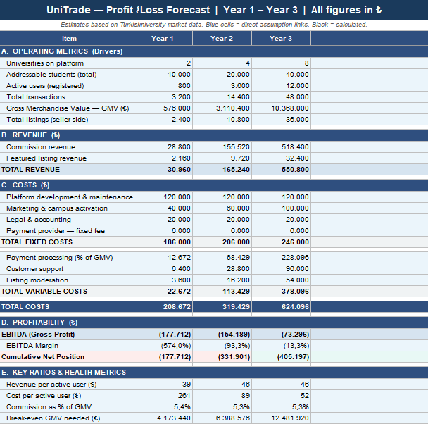
“estimated by the help of AI”
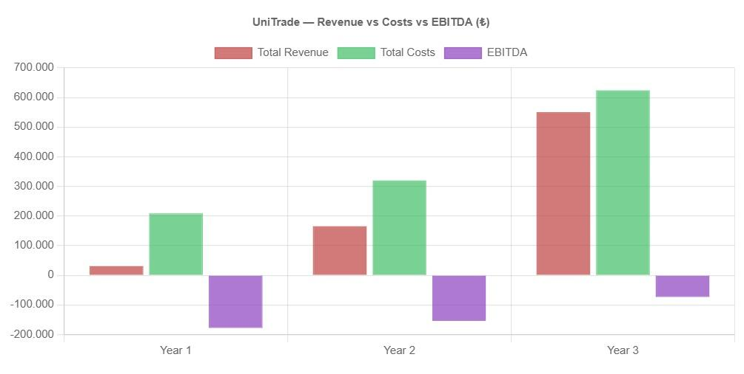
Notes:
Please select at least 25 relevant questions for your EC business model by referring to Appendix B.
Add the questions to the relevant sections (i.e. 3.1, 3.2, 4.1, ...).
Answer these questions by discussing among the team members.

i. Use Case Scenario & Customer Journey Map

Use Case Scenarios

Scenario 1. Buyer
Ayşe is a second year MIS student who needs the MIS220 textbook. She signs up on UniTrade with her KHAS email, searches by course code, and finds a verified senior selling the book for 300 TL. She messages the seller, pays via iyzico (funds held in escrow), and meets at the library. After confirming receipt in the app, the escrow releases payment and she leaves a five star review.

Scenario 2. Seller
Mehmet is a fourth year Economics student clearing out last year's textbooks. He scans each ISBN; UniTrade auto fills metadata and links the correct course code. He publishes five listings in ten minutes, coordinates meet ups via in app chat, and earnings accumulate in his wallet for withdrawal.
Scenario 3. Membership / Student Verification
Zeynep is a first-year student who wants to use UniTrade. She signs up with her university email address. The system sends a verification code to her email and checks whether she is an active student. After completing verification, she creates her profile and can now browse listings, message sellers, and post items for sale.

Journey Map. Buyer (Ayşe)

Stage | Actions | Feelings | Pain Points | Opportunities
Awareness | Hears about UniTrade from a friend. | Skeptical | Distrusts unknown C2C apps. | Verified student badge.
Search | Signs up with KHAS email. Searches MIS220. | Hopeful | Generic search on other apps. | Course code filtering.
Evaluation | Compares listings. Messages seller. | Cautious | Hard to judge condition. | Standard condition rubric.
Purchase | Pays via iyzico. Funds escrowed. | Anxious | Fear of payment fraud. | Clear escrow messaging.
Handover | Meets seller on campus. Confirms receipt. | Relieved | No show sellers. | Suggested safe meet up points.
Post Sale | Rates seller. Enables alerts. | Delighted | Forgets to leave reviews. | Auto prompted reviews.

Journey Map. Seller (Mehmet)

Stage | Actions | Feelings | Pain Points | Opportunities
Onboarding | Verifies KHAS email. Sets up payout. | Curious | Unclear commission. | Transparent fees upfront.
Listing | Scans ISBN. Auto fills metadata. | Productive | Pricing uncertainty. | Suggested price algorithm.
Engagement | Replies to buyer messages. | Engaged | Time wasters and spam. | Buyer intent score.
Transaction | Accepts offer. Payment escrowed. | Confident | Disputes after handover. | Condition agreed at listing.
Handover | Meets buyer. Confirms in app. | Accomplished | Last minute cancels. | Late cancel penalty.
Retention | Withdraws earnings. Re lists items. | Loyal | No reason to return. | Earnings recap and referrals.

Key Insights
Three moments matter most: KHAS verification at sign up (trust foundation), iyzico escrow at payment (what differentiates UniTrade from informal trades), and the on campus handover (where digital meets physical). The biggest opportunities sit in Retain, which aligns with the value chain matrix conclusion that Act and Retain are the highest leverage process categories.

j. Balanced Scorecard (BSC)
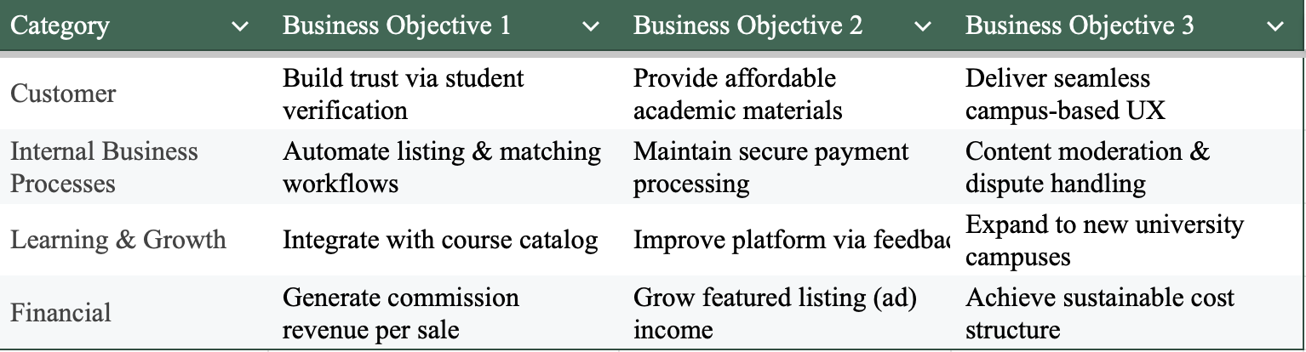

k. Value Chain Analysis

Category | Business Process 1 | Business Process 2 | Business Process 3
Attract | Campus social media campaigns | University email onboarding | Student referral program
Interact | Course-code filtered search | Seller profile & rating browsing | In-app buyer–seller messaging
Act | Purchase confirmation & payment (iyzico) | Campus meet-up coordination | Listing management & auto-matching
React | Dispute resolution & moderation | Refund & return handling | Post-sale review & rating system
Retain | Semester-start push notifications | Re-listing reminders for sellers | Loyalty discounts & UniTrade Plus

l. Matrix 1
A 0–3 scale was used in Matrix 1 (0 = no link, 1 = weak, 2 = medium, 3 = strong). The row totals were then used to compare importance. In our table, 20 was accepted as the threshold, so scores of 20 and above were considered more important.

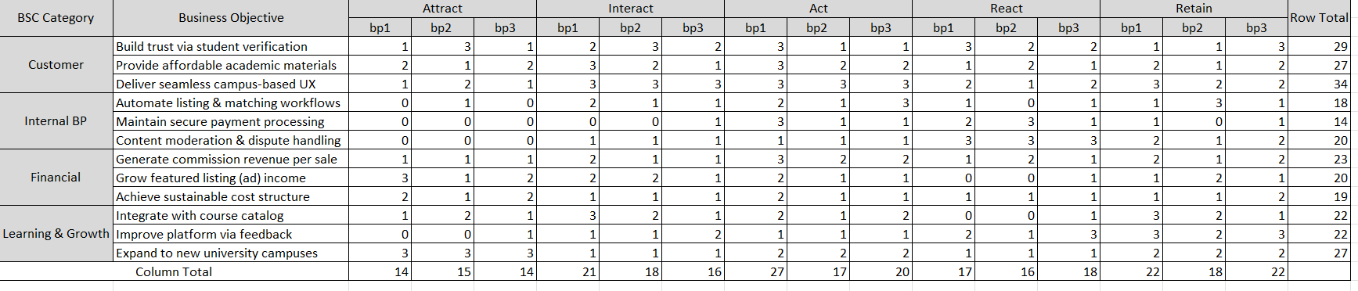

m. Prioritization
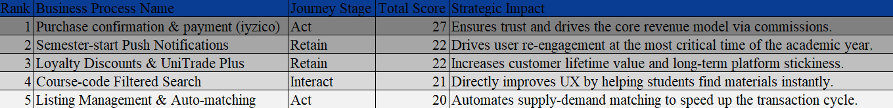

Conclusion
Based on Matrix 1, the median alignment score for business processes is 18. The analysis identifies "Purchase confirmation & payment (iyzico)" as a significant positive performer with 27 points, standing out well above the median as the critical backbone for trust and revenue. Processes such as "Semester-start push notifications" and "Loyalty programs" (22 points each) also rank significantly above the median, reinforcing their strategic priority. Consequently, investment and development will be focused on these high-impact processes to ensure maximum alignment with the core business objective.

n. Matrix 2

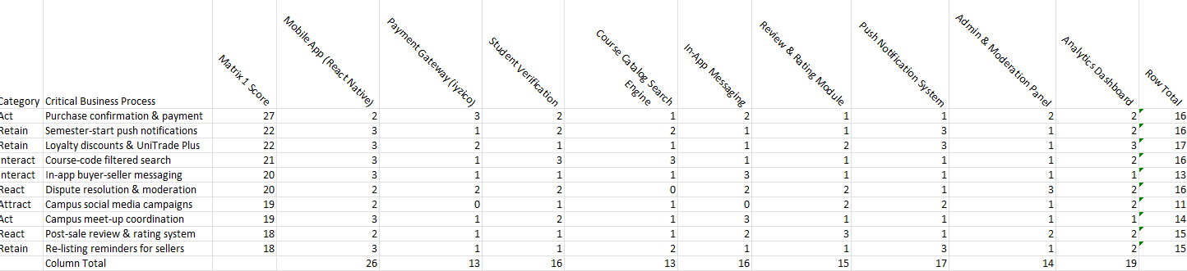
o. Prioritization of E-Business Applications

Rank | Application | Score
1 | Mobile App (React Native) | 26
2 | Push Notification System | 17
3 | Payment Gateway (iyzico) | 16
4 | Admin & Moderation Panel | 16
5 | In-App Messaging | 15
6 | Analytics Dashboard | 19
7 | Review & Rating Module | 15
8 | Student Verification (Univ. DB API) | 15
9 | Course Catalog Search Engine | 13

The Mobile App scores highest because it is the foundation that all other processes depend on — without it, no business process can be executed. The Push Notification System and Payment Gateway (iyzico) follow closely, directly supporting the two highest-priority processes from Matrix 1: semester-start retention and secure payment. The Admin & Moderation Panel ranks high due to its role in dispute resolution and content moderation, which are critical for platform trust. Lower-scoring applications such as the Course Catalog Search Engine and Analytics Dashboard are still necessary but represent secondary investment priorities.

p. Technology & Infrastructure Requirements

UniTrade requires a mobile-first software stack built around a React Native application for iOS and Android, supported by a cloud-hosted backend — preferably AWS or Google Cloud — to ensure scalability as the platform expands across universities. On the software side, core requirements include iyzico payment gateway integration for secure escrow-based transactions, a university database API for student verification via institutional email, a real-time messaging module, an automated push notification service such as Firebase Cloud Messaging, and an admin panel for content moderation and dispute handling. Hardware infrastructure will be entirely cloud-based with no on-premise servers required, relying on managed database services such as PostgreSQL and object storage for listing images. External services needed include SSL certification for secure data transmission, a third-party analytics tool such as Mixpanel or Firebase Analytics for user behavior tracking, and SMTP or SMS services for verification and notification delivery.

Section III (Prototype/Design):

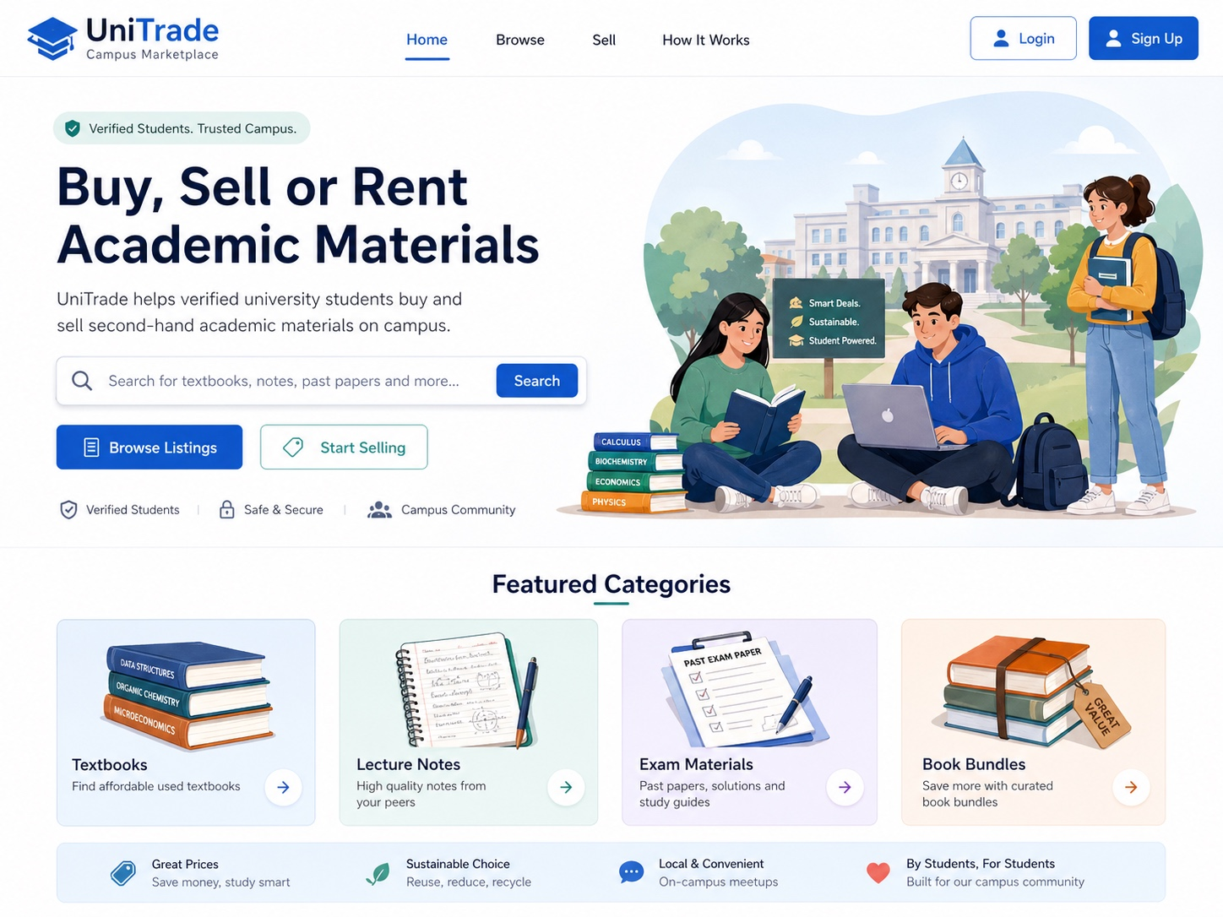

Home Page of Website

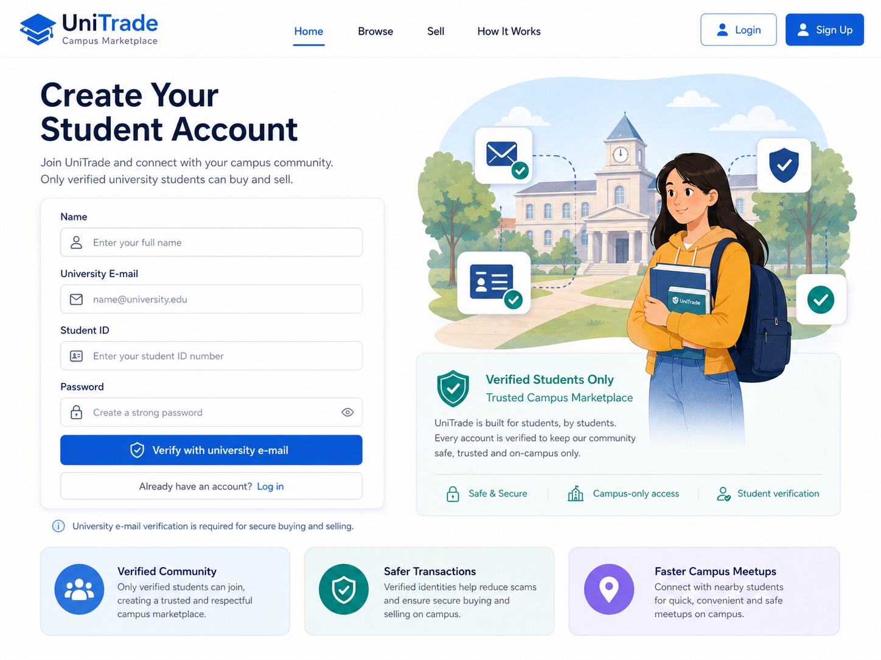
Log in Page
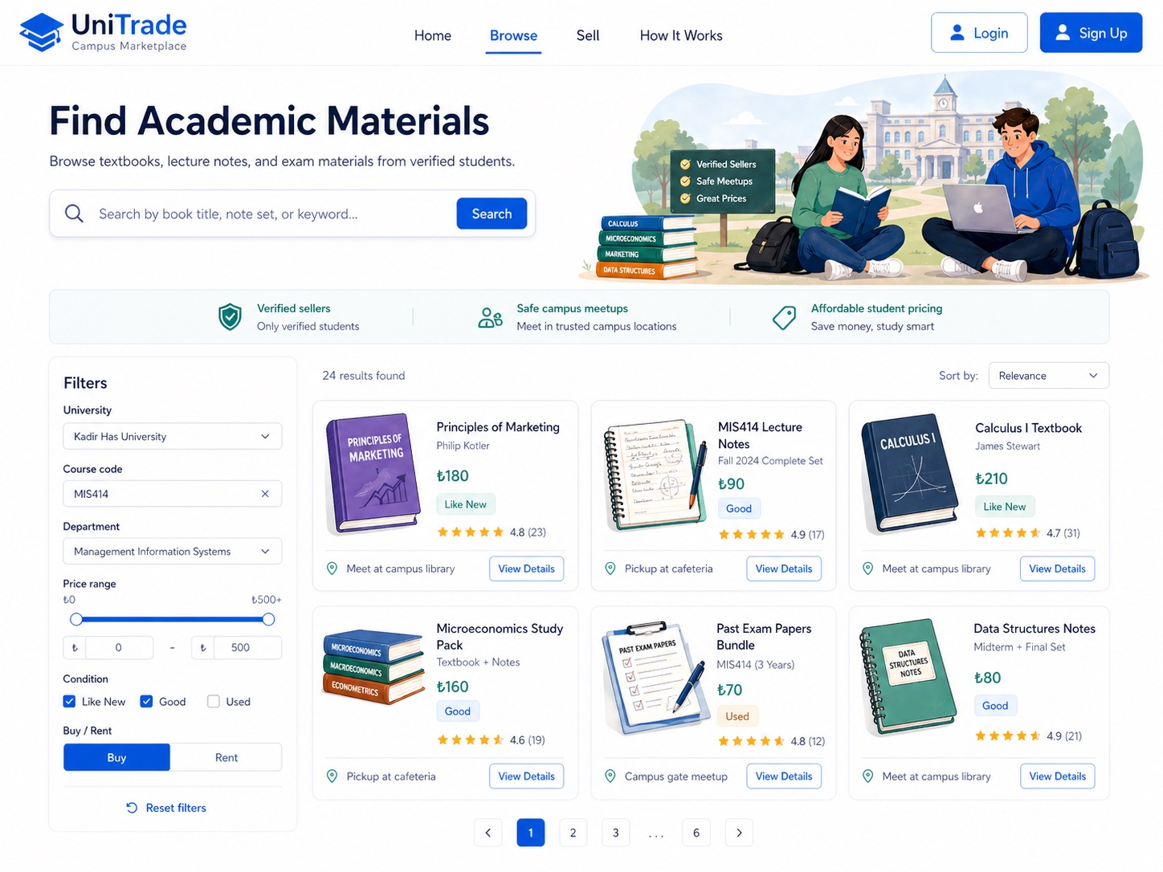
Search Page
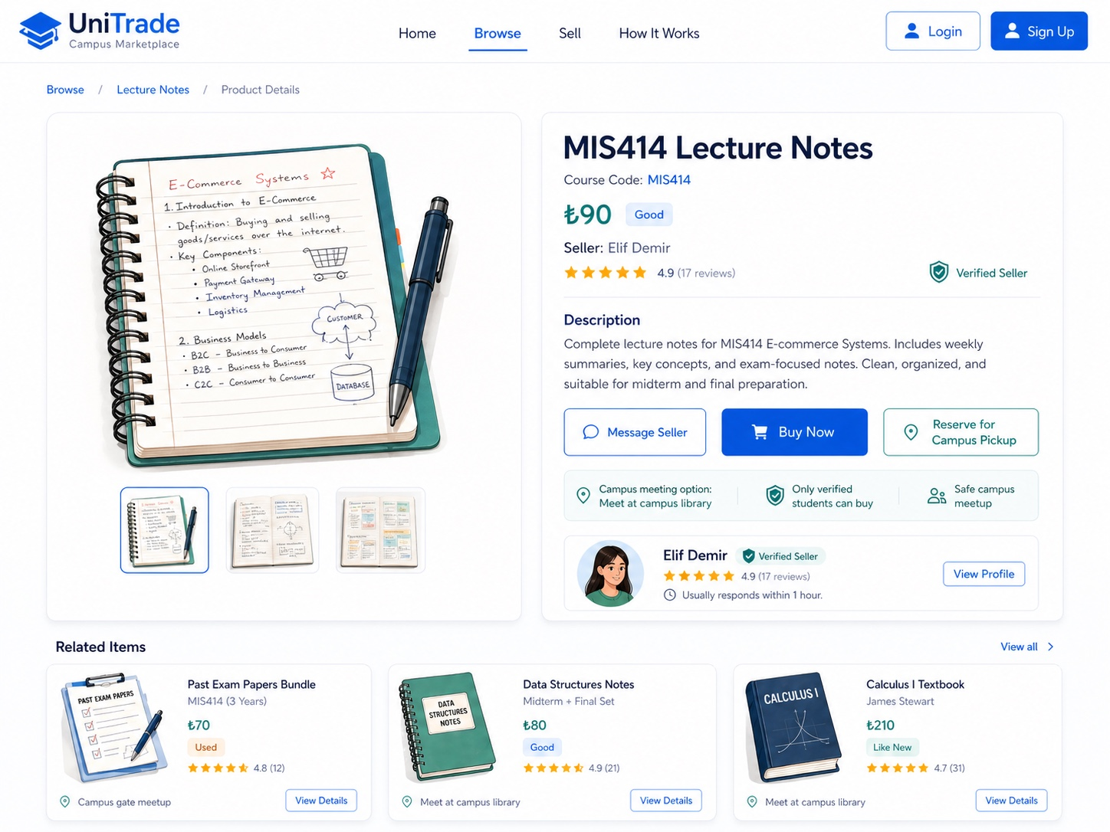
Product - Detail

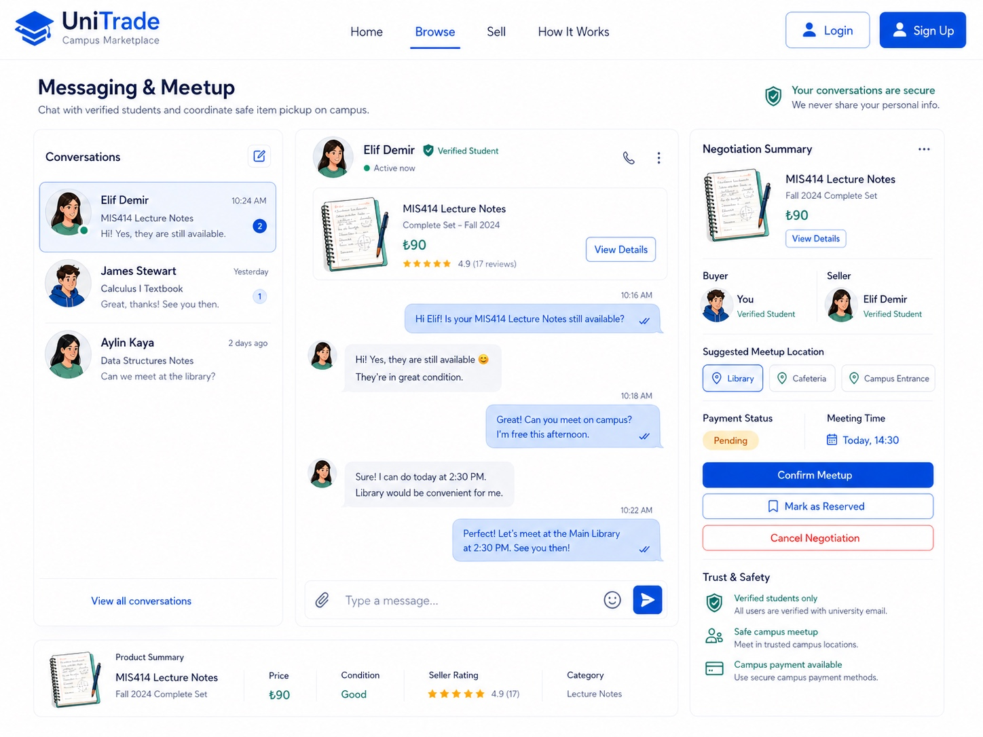
Chat with seller

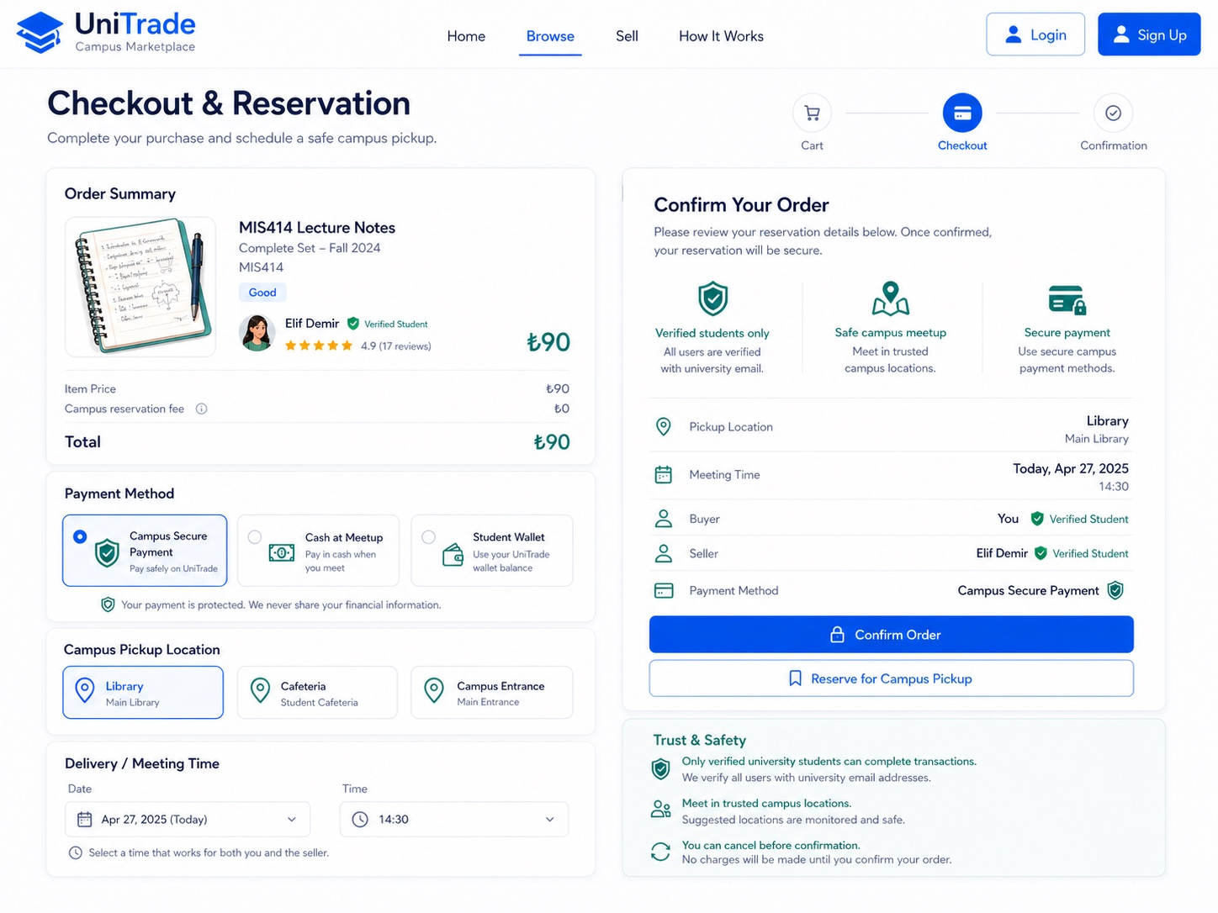
Checkout and Reservation

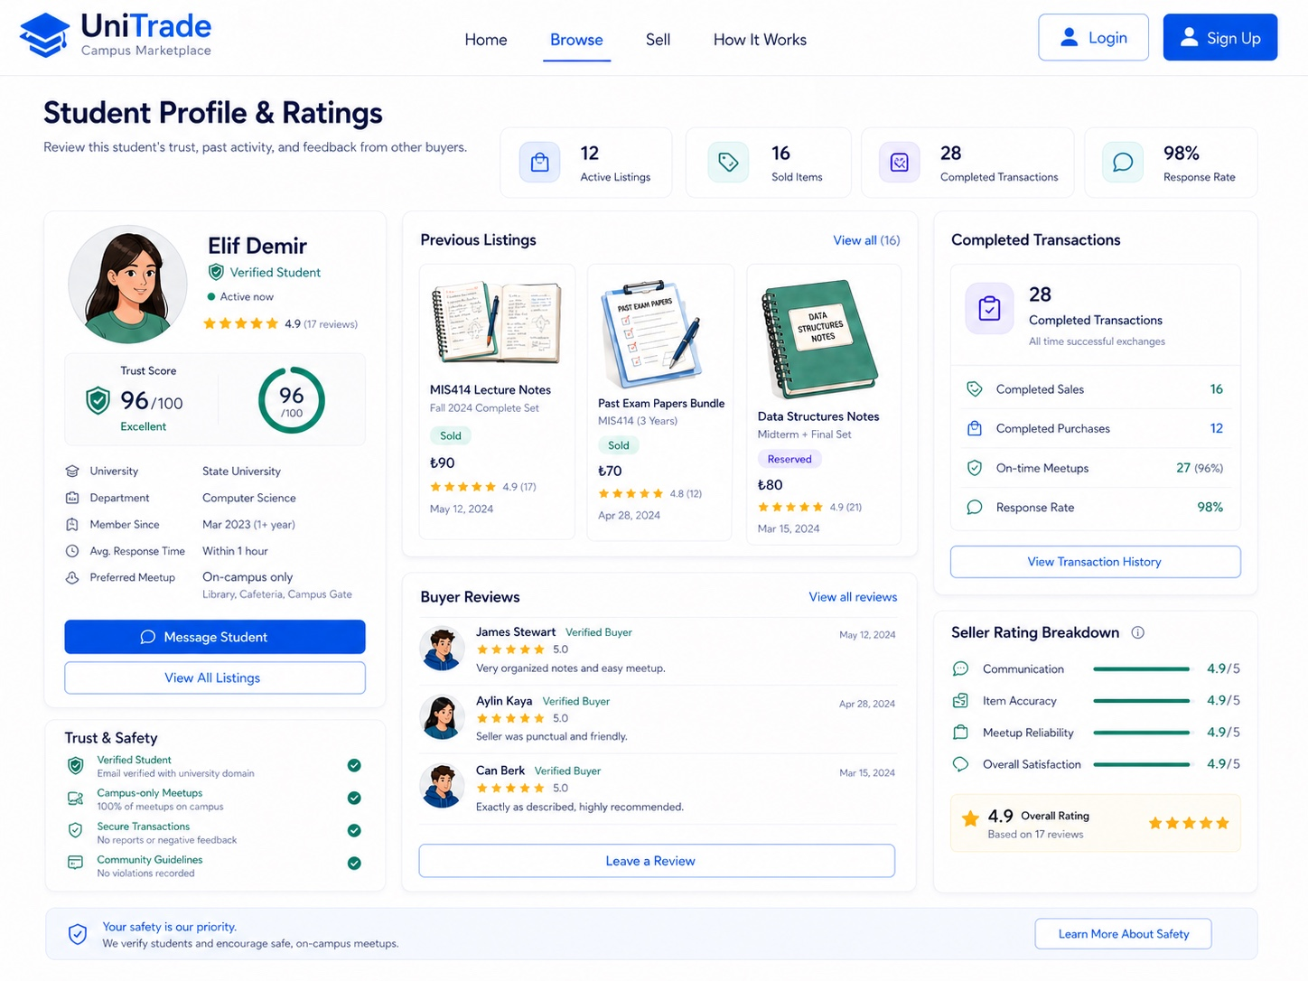

Profile and Rating Page

